**ECSE 4770 LAB 1 REPORT**

Yuchen Wang, Rin: 661960546, section 2

**Introduction**

* The primary object of this lab is to help students get familiar with the hardware design language, Verilog, and the method to use the FPGA board and its software, Quartus 15.
* In this lab, students need to build an 8-bit D-Flipflop, 4x4 multiplier, and a 16-8 MUX with Verilog. After testing the components’ function by iVerilog, students will build components in Quartus and simulate them in Quartus.
* The top level of the lab contains the three components. The logic circuit should be able to get two 4-bit binary inputs and then multiply them together. The result of the multiplier should be saved in the 8-bit D-Flipflop. A push-button on the FPGA board should control the D-Flipflopd to save the result from the multiplier. The MUX should be able to choose between the multiplier result and the D-Flipflop saving data. Another push-button on the FPGA board will control the MUX. Output data will show in heximal form on the FPGA board by the given segments in the lab template.

**Schematic**

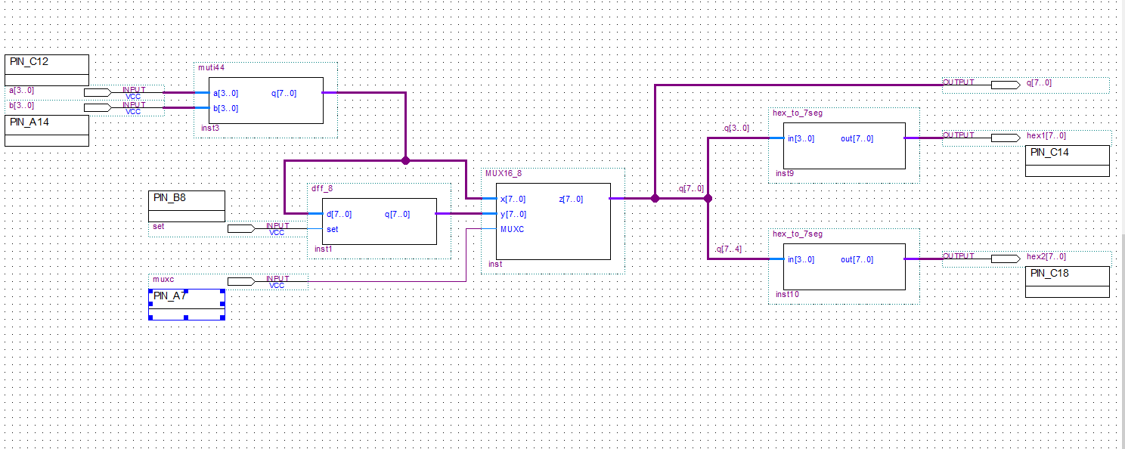

Figure 1: Top Level Circuit Schematic

**Verilog Code**

* **8-bit D-Flipflop**

module dff8(input [7:0]d, input set, output reg [7:0]q );

always @(posedge set) begin

    q <= d;

end

endmodule

This is the 8-bit D-Flipflop code. Input set is a 1-bit binary input that controls the flipflop. When the set has a positive edge, input d will be saved to output q. In Quartus, the input, set, connects to the push-button on the FPGA board.

* **4*4 Multiplier**

module muti44 (input [3:0]a, input [3:0]b, output [7:0]q);

    assign q = a*b;

endmodule

Verilog provides a straightforward way to fulfill the multiplier. Using the symbol of time can multiply the two inputs together.

* **16-8 MUX**

module MUX16_8 (input [7:0] x, input [7:0] y, input MUXC, output [7:0] z);

  assign z = MUXC?x:y;

endmodule

In the 16-8 MUX, conditional statement is used to fulfill the MUX function. For high input, MUXC, the output will be x. Otherwise, the output will be y.

**Simulation Result**

* **8-bit D-Flipflop**

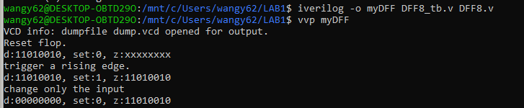

Figure 2: 8-bit D-Flipflop iVerilog Test Branch Result

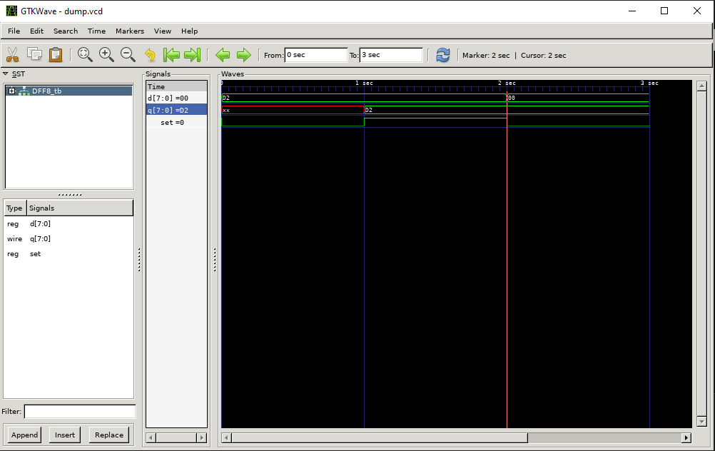

Figure 3: 8-bit D-Flipflop Wave Form Output

The flipflop can save data when the input, set, has a positive edge. And it stores the data correctly when the input changes.

* **4*4 Multiplier**

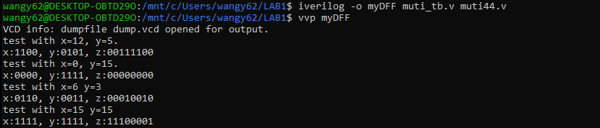

Figure 4: 4*4 multiplier iVerilog Test Branch Result

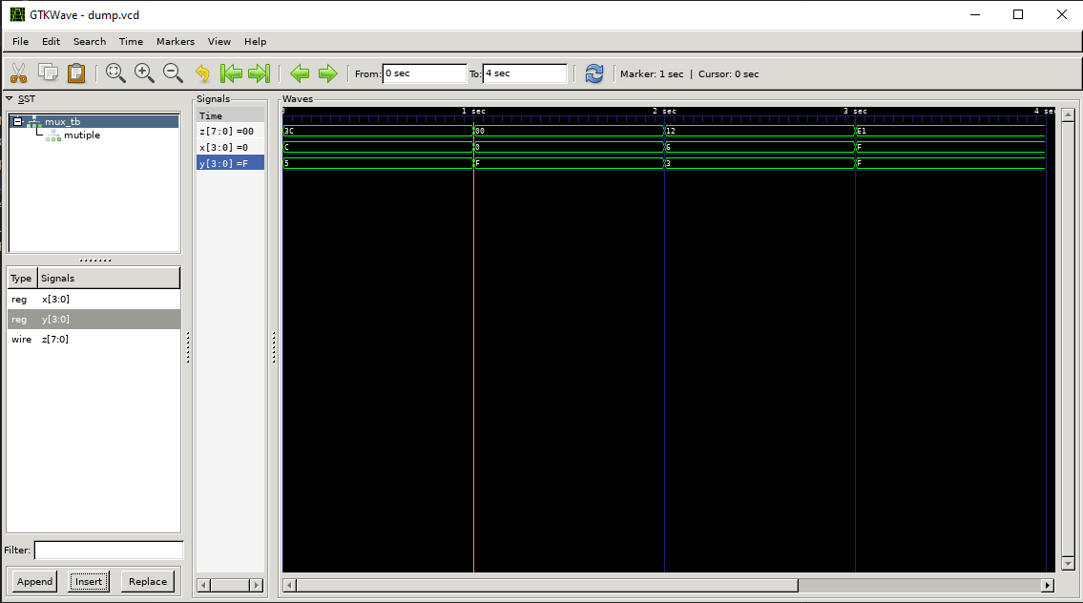

Figure 5: 4*4 multiplier Wave Form Output

The outputs of the multiplier are as expected—both the zero operands and none zero operands.

* **16-8 MUX**

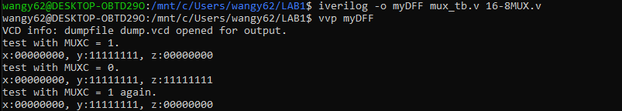

Figure 6: 16-8 MUX iVerilog Test Branch Result

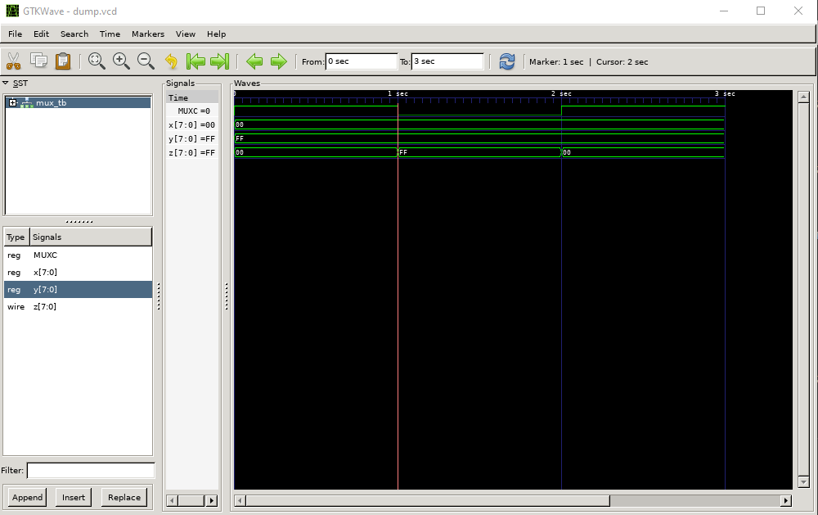

Figure 7: 16-8 MUX Wave Form Output

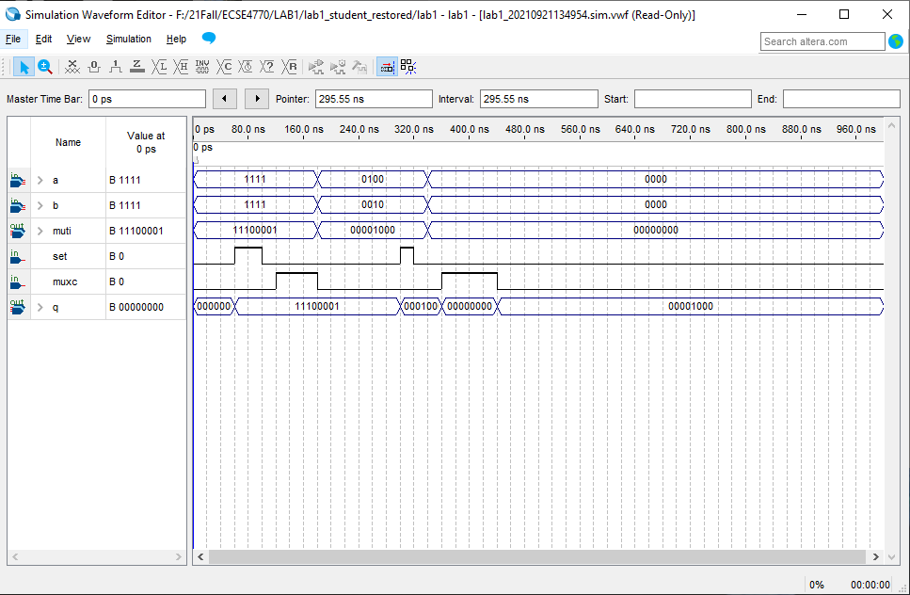

Figure 8: 16-8 MUX Quartus Simulation Result

In Figure 8, the muti pin is the output of the multiplier, set is for D-Flipflpo, and muxc is the input of 16-8 MUX. After 320ns, the output 0b0000 1000 is saved in the D-Flipflop, the output of the multiplier is 0. The muxc can determine which data the output q is.

**FPGA Result**

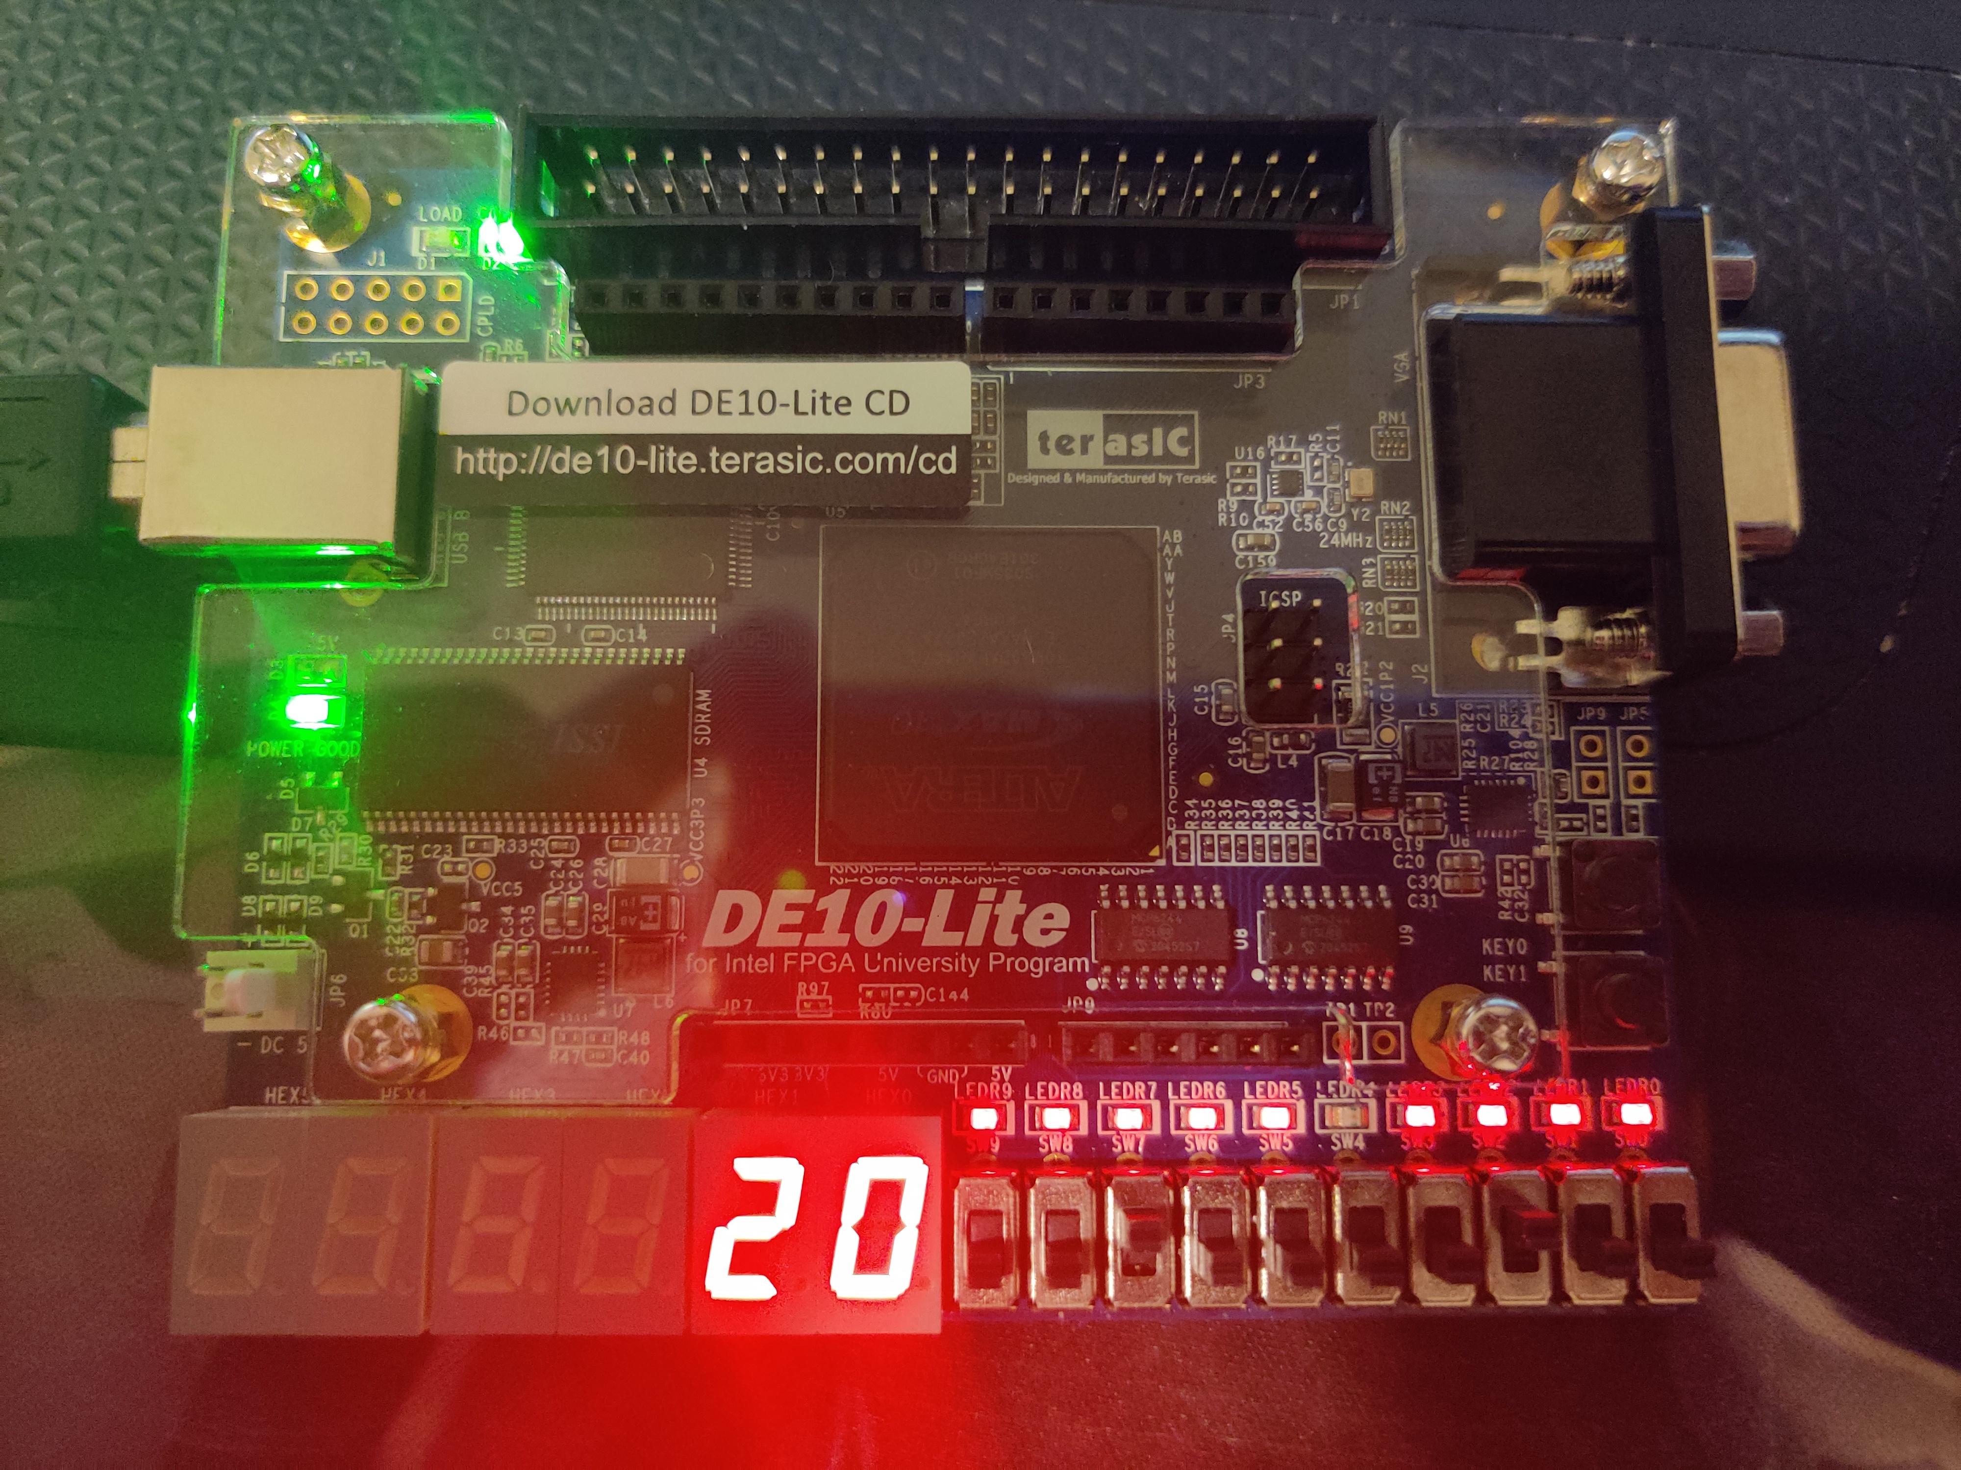

Figure 9: multiplier output with non-zero operands

Here the two inputs are 8 and 4, the result is 0x20.

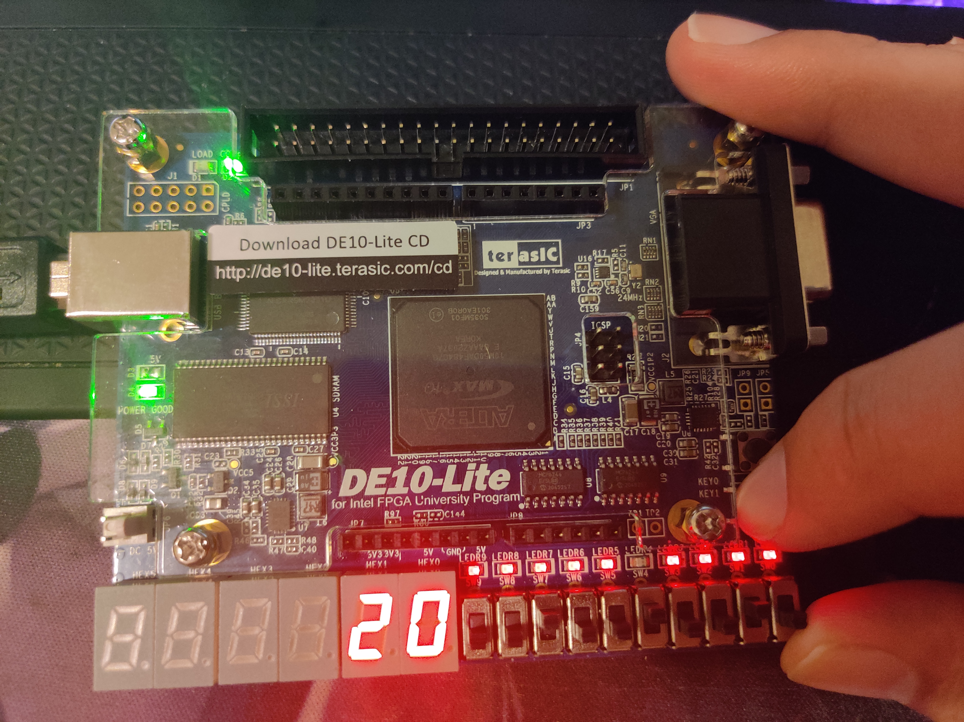

Figure 9: DFF output with non-zero operands

The inputs here are 9 and 2, the multiplier output is 0x12, but here with the push-button of MUX pushed, the output is the previous result 0x20.

**Conclusion**

The lab result turns out as expected. The student learned how to write Verilog code, simulate on Quaturs, and use the FPGA board to test the design.